Login

Link: http://www.liza-line.com/wp-admin/

The login information is:
username: Lizaline
Password: tijdelijkwachtwoord

Add new product group/category

1. Click in the menu in the dashboad on products – add new
2. Choose the right template: Products Listing

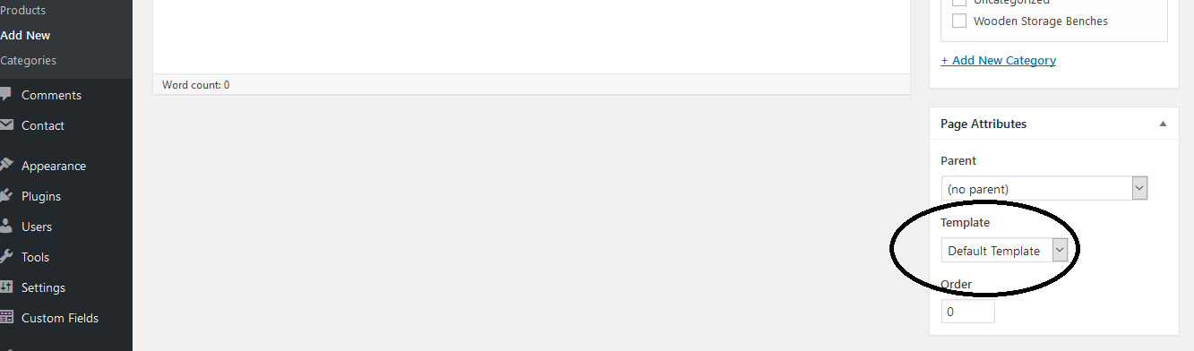
3. Enter the name of the product group/category in the box ‘Enter title here’
4. Check the box ‘Product Group’ under categories (on the right sidebar)
5. Add a product to the category page via the following steps:

a. Product List 1 Images array:
1. Open another screen with the Liza Line Dashboard and go to media.
2. Click on the image you want to add to the category page – copy the URL
3. Add the url from the image in the big white box
4. If you want to add more pictures, copy a new url from an image and add it to the white box (seperated by comma’s)

b. Product name:
Add the name of the product

c. Product description
Add the price or some other information about the product

d. Product link
Add the link to the the product if this page is already made. Otherwise, you can add this later.

e. Product CTA
This is the description from the link, for example: See product

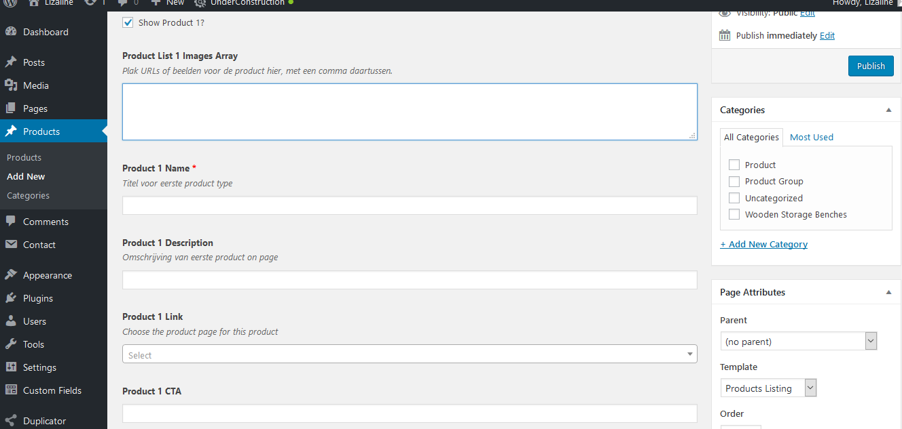
6. You can add 8 products for each category. If you want more, let me know.

Add new product

1. Click in the menu in the dashboad on products – add new
2. Choose the right template: Individual Product
3. Enter the name of the product in the box ‘Enter title here’
4. Check the box ‘Product’ under categories (on the right sidebar)
5. Add the product information via the next steps:

a. Product description
This is the information about the product that is shown in the box right.

b. Product Price
Add the price of the product with the valuta sign

c. Images
Add 1 to 3 product images. When you’ve selected an image, always fill in the information on the right (see below) for SEO reasons:Title, Alt Text & Description (no caption)
Add at least the keyword from the page, this should be the same as the name in the product title.

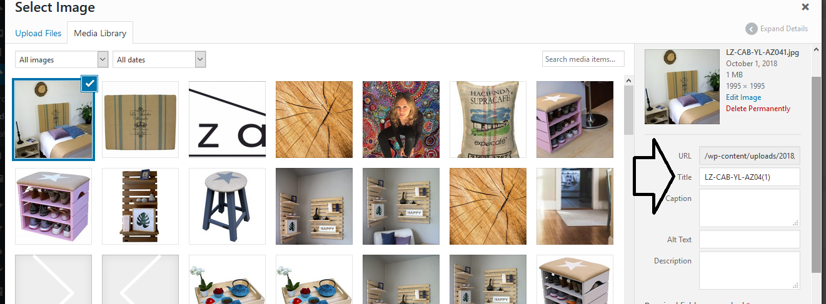
6. In stock: If a product is out of stock, deselect the box
7. Link Amazon: this is the link to the product page on Amazon where visitors can buy your product.

8. Similar products, follow the next steps:

a. Add the title you like to show instead of similar products, for example ‘Related Products’ our ‘Products you may also like’
b. Select 1 to 3 similar products. You can choose from another existing product page

Menu

